Final Project

INNOVATION IN TIC : Information and Communication Technologies (TIC)
& Related Tools
Groupe 33

- Table of contents

- Introduction : 3
- Overview of (TIC): 3
- Google Services: 4
- Microsoft Tools: 7
- Version Control with Git and GitHub: 12
- HTML and CSS : 13
- Difference between microsoft tools & google service : ……………………………………………………………14
- Conclusion : 15

- Introduction :

. Welcome to a journey into the dynamic realms of Information and Communication Technologies (TIC) and the cutting-edge tools that define our digital landscape. This project unravels the intricate tapestry of TIC, spotlighting key players like Google services and Microsoft tools.
As we navigate through the interconnected web of communication, collaboration, and innovation, we delve into the transformative impact of these technologies on our daily lives.
Join us in exploring the present and future of digital connectivity, where TIC serves as the catalyst for a globally connected and technologically empowered society.
- Overview of (TIC):

Information and Communication Technologies, or TIC, are like the magic threads that connect our digital world. They help us talk, share, and learn using computers, phones, and the internet. Imagine TIC as the language that makes our devices understand each other.

TIC includes cool tools like Google services and Microsoft apps that let us send messages, create documents, and work together, even if we're far away. It's the reason we can watch videos on our phones, play games online, and learn new things with just a click.

Think of TIC as the friendly helper that makes our gadgets do amazing things, bringing people closer and making our lives
easier in this big, digital adventure.

- Google Services:

Google offers a suite of services that have become integral to both personal and professional digital experiences. Let's delve into some of the key services, exploring their functionalities, use cases, and the benefits they bring to users.

- Gmail:
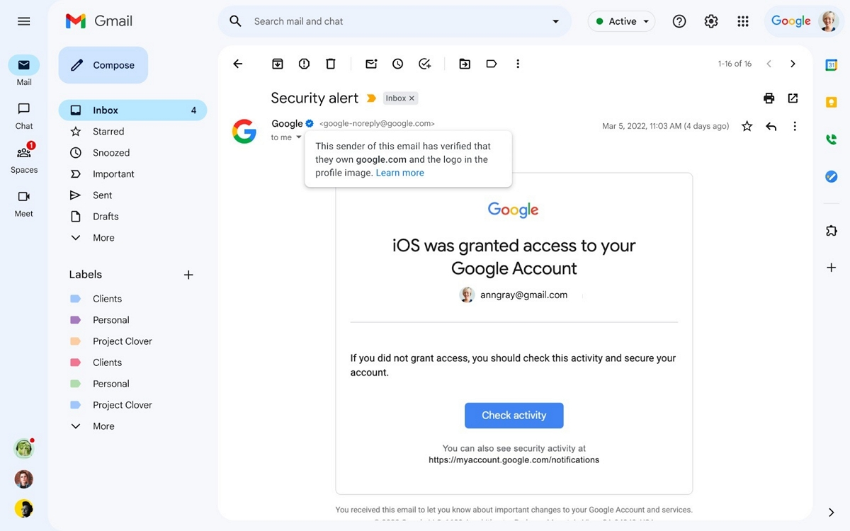

- Description: Gmail is Google's email service, offering a user-friendly interface and robust features for efficient communication.

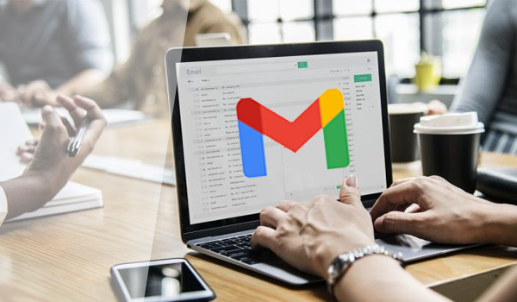
- Use Cases:
  - Professional Email Communication.
  - Seamless Integration with Other Google Services.
- Benefits:
  - Generous Storage Space (15 GB).
  - Advanced Filtering and Organization.

2 Google Drive:
- Description: Google Drive is a cloud storage and file-sharing service, enabling users to store, access, and collaborate on documents.

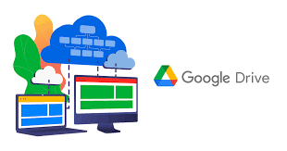

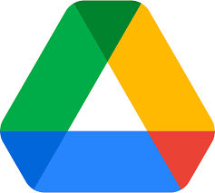

- Use Cases:
  - Collaborative Document Editing.
  - Secure File Storage and Sharing.

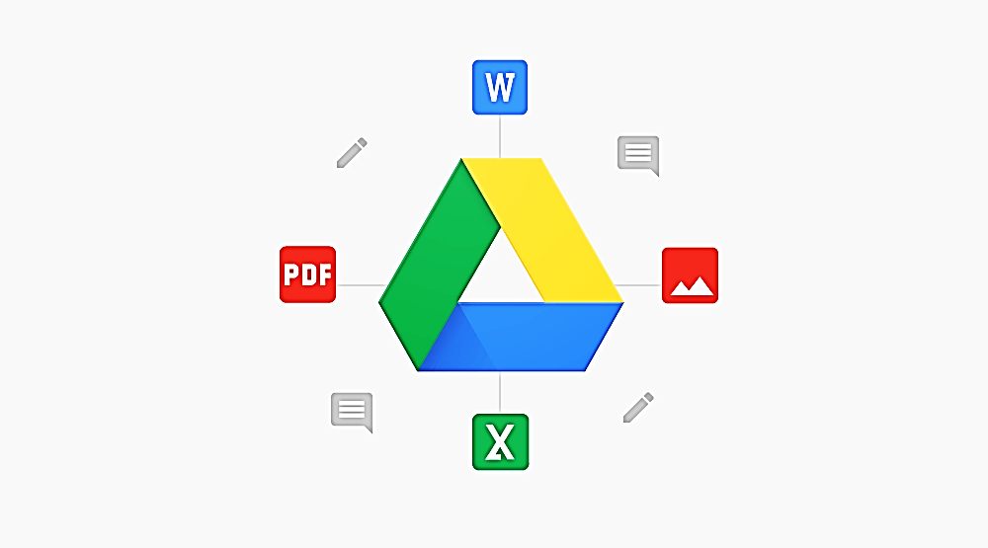

- Benefits:
  - Real-time Collaboration.
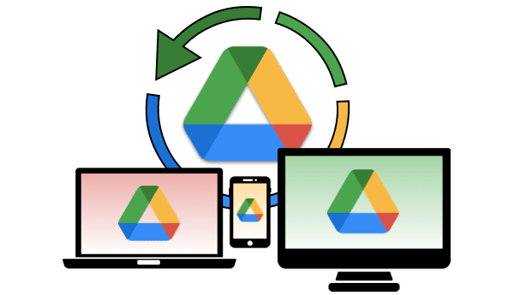
  - Accessibility from Any Device.

3 Google Docs:
- Description: Google Docs is a cloud-based word processing tool, allowing users to create and edit documents collaboratively.

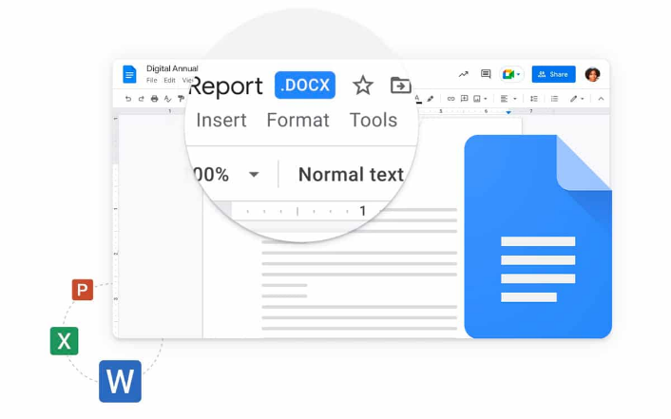

- Use Cases:
  - Team Document Creation.
  - Version Control and Editing History.
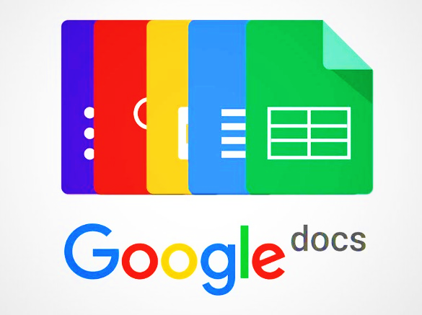

- Benefits:
  - Real-time Editing and Comments.
  - Collaboration (simultanrous).
- Microsoft Tools:

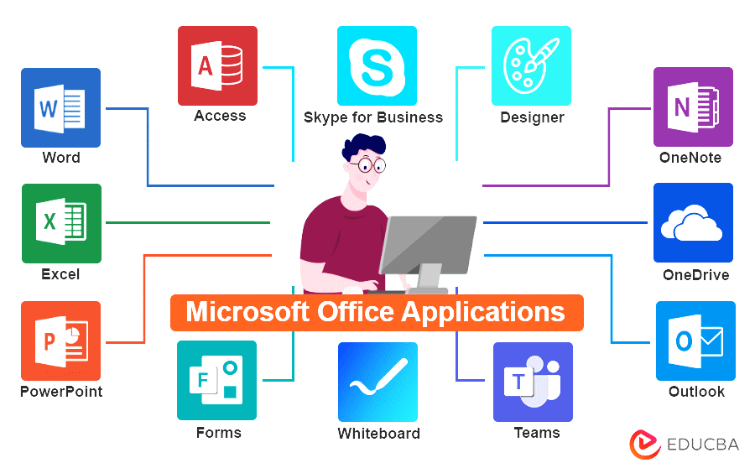

Microsoft offers a suite of essential tools that cater to diverse user needs, from document creation and collaboration to team communication and file storage. Let's explore the functionalities and integration possibilities of key Microsoft tools.
- Microsoft Office Suite:


- Microsoft Word:
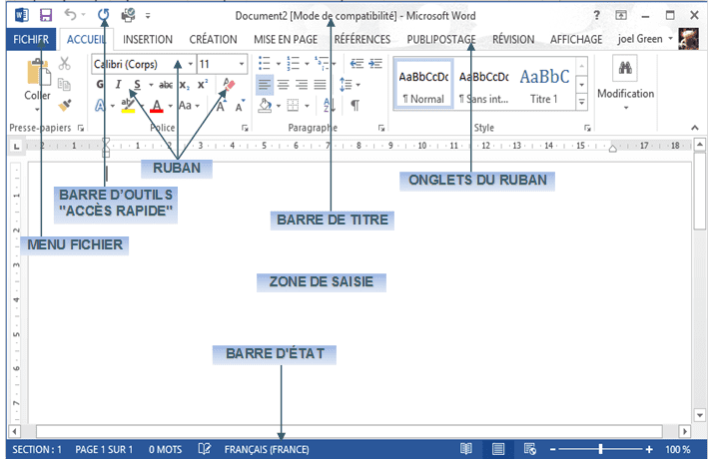
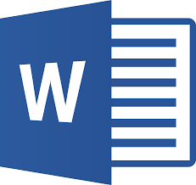
- Description: Microsoft Word is a word processing software that allows users to create, edit, and format documents with a range of features.

- Use Cases:
- Document Creation and Editing.
- Formatting for Reports, Essays, and Professional Documents.
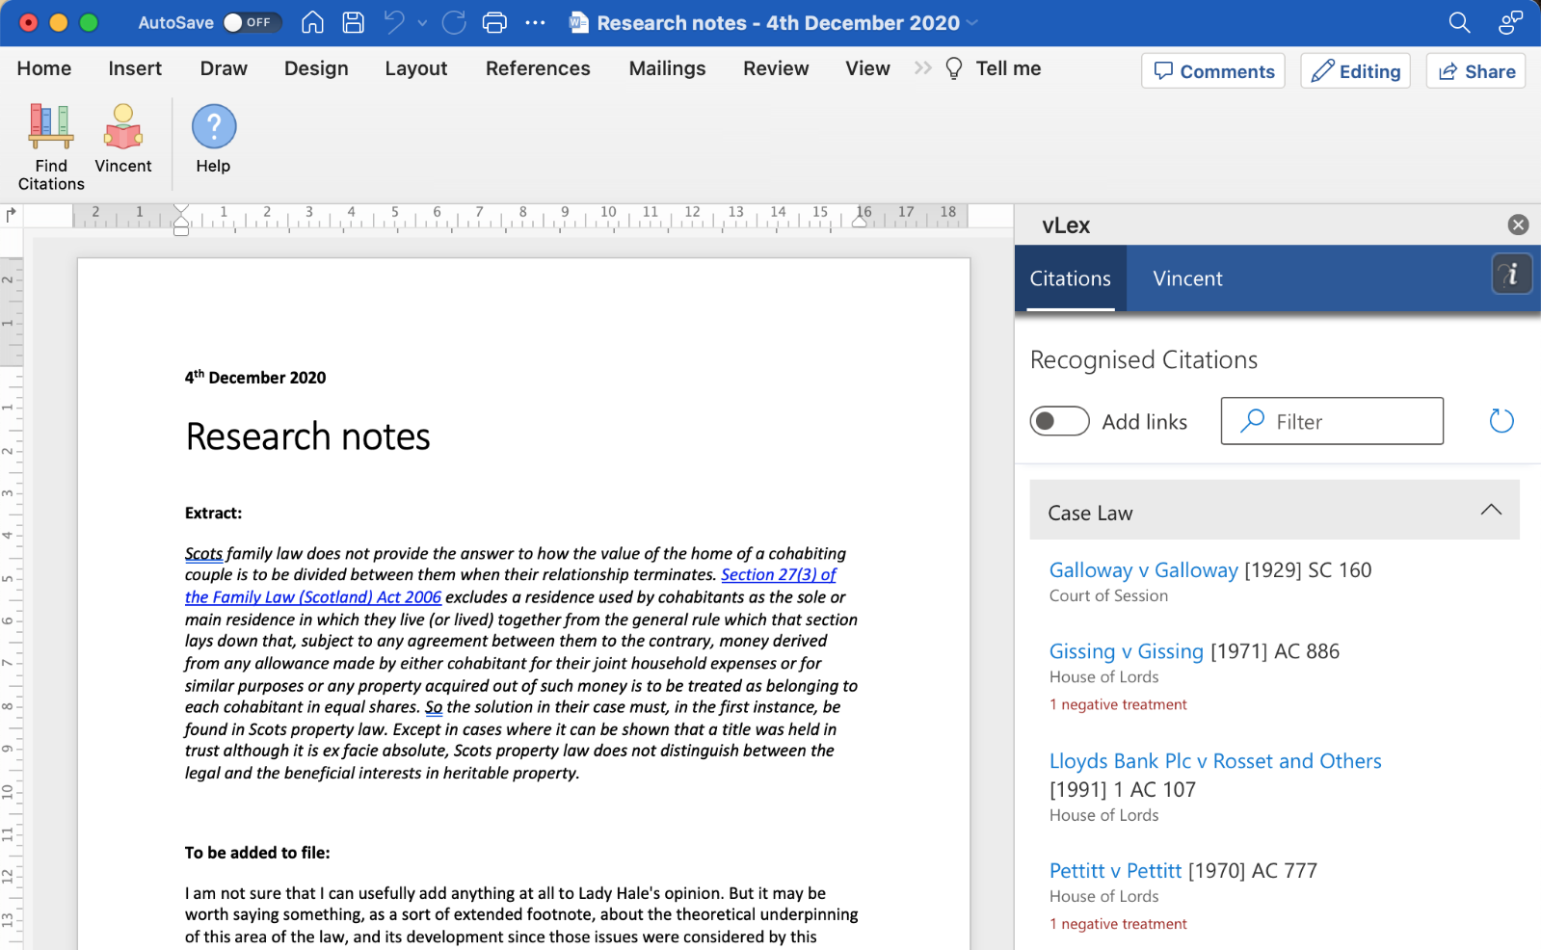
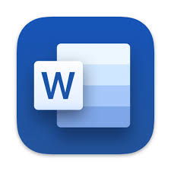
- Benefits:
- Rich Formatting Options.
- Collaboration through Track Changes and Comments.
- Integration with Other Microsoft Office Apps.

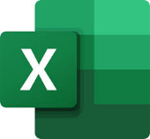
- Microsoft Excel:
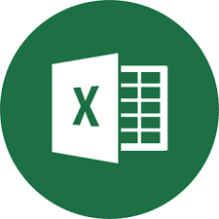
- Description: Microsoft Excel is a spreadsheet software for data analysis, calculation, and visualization using tables and charts.

- Use Cases:
- Data Analysis and Reporting.
- Budgeting and Financial Planning.

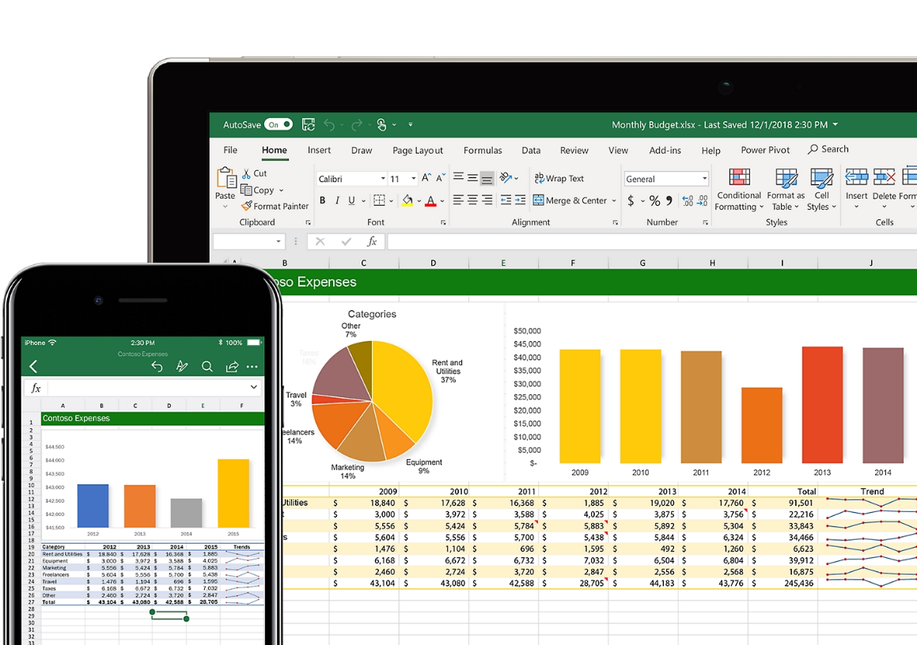

- Benefits:
- Powerful Formulas and Functions.
- Data Visualization with Charts.
- Collaboration through Shared Workbooks.

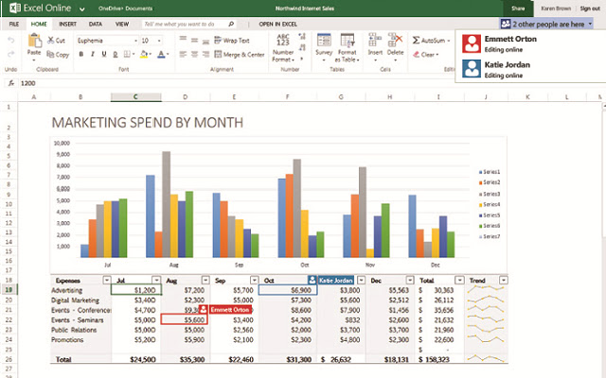

- Microsoft PowerPoint:
- Description: Microsoft PowerPoint is a presentation software for creating slideshows with text, images, and multimedia elements.

- Use Cases:
- Business Presentations.
- Educational Lectures.
- Professional Slideshows.

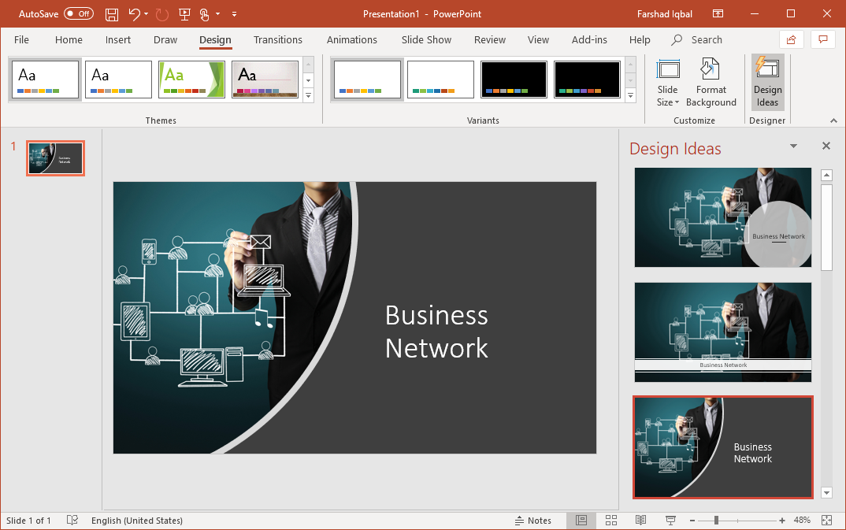
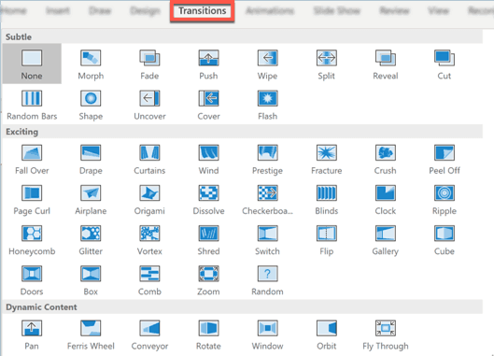

- Benefits:
- Easy-to-Use Interface.
- Slide Transitions and Animations.
- Integration with Other Microsoft Office Apps.
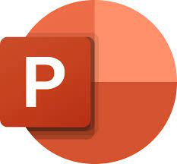

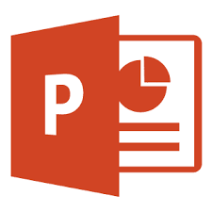

- Version Control with Git and GitHub:


Version control with Git and GitHub is like a superpower for software developers and anyone working on projects. Imagine you're writing a story, and you want to keep track of every change you make—Git helps you do exactly that for your code.
- Significance:
- Time Travel for Code: Git allows you to go back in time and see every version of your project. If something goes wrong, you can easily fix it.

- Team Harmony: When many people work on a project, Git helps everyone sync up their changes. No more stepping on each other's toes!
- Examples and Usage Scenarios:
•Masterpiece Creation: Git ensures harmony in team website development, letting each member contribute without chaos.
•Bug Squashing Magic: Git allows rewinding to fix accidental mistakes, ensuring a flawless project.

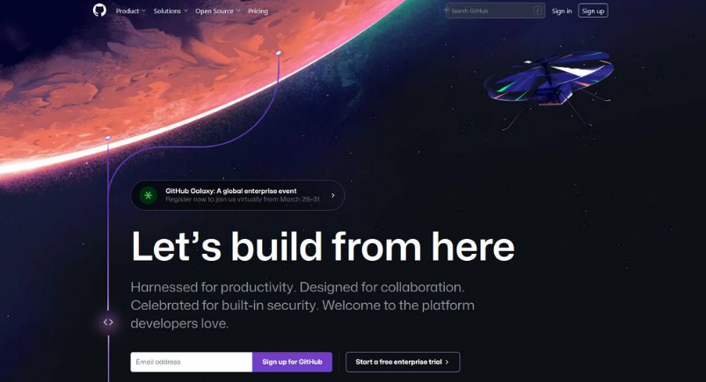
•Global Collaboration Hub: GitHub turns Git into a virtual meeting place, connecting coders worldwide for seamless collaboration.
- HTML and CSS :

HTML (Hypertext Markup Language):
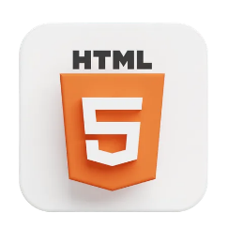
- Purpose: HTML is the standard markup language used to create the structure of web pages. It defines the elements and layout of content on a webpage.
- Key Components: Uses tags (e.g., <p> for paragraphs, <h1> for headers) to structure content.
- Functionality: Provides the backbone for web content, allowing browsers to interpret and display text, images, links, and other elements.
CSS (Cascading Style Sheets):
- Purpose: CSS is a styling language used to control the presentation and layout of HTML elements on a webpage.

- Key Components: Utilizes rules (e.g., color: blue;, margin: 10px;) to define styling properties.
- Functionality: Enhances the visual appeal of web pages by specifying fonts, colors, spacing, and positioning of HTML elements.
Integration:
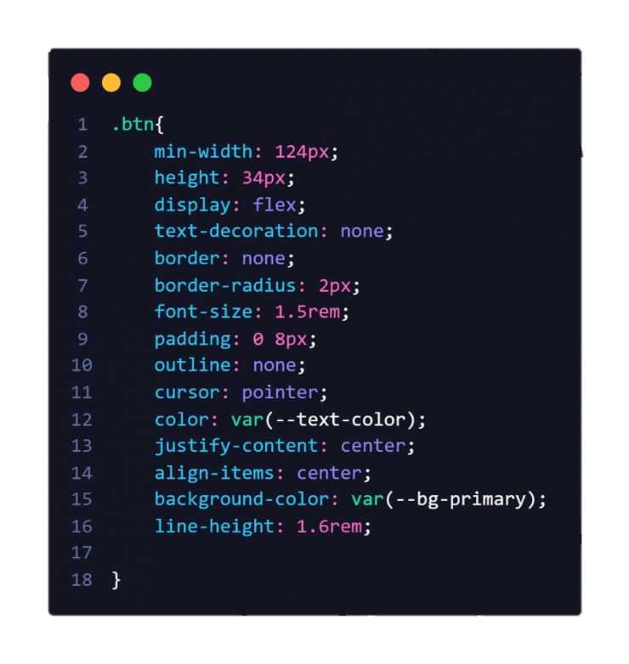
HTML and CSS work together; HTML defines the structure, and CSS enhances the visual presentation, creating a harmonious and aesthetically pleasing web experience.

Difference between microsoft tools & google service :

Feature | Microsoft tools | Google service
Document creation | Word | Google Docs
Spreadsheet | Excel | --
Presentation | Powerpoint | --
Collaboration | Available (Office 365) | Inherent_(Real-time collaboration)
Storage | OneDrive | Google Drive
Email Service | Outlook | Gmail
Offline Access | Available | Available
Integration | Seamless integration with other Microsoft services | Native_integration_across Google Ecosystem
Real-time Editing | Requires Office 365 | Inherent (Google Docs)
Cost | Subscription-based | Free with optional premium plans

- Conclusion :

In conclusion, our exploration of Information and Communication Technologies (TIC) and associated tools reveals a digital landscape where efficiency and collaboration are paramount. Google services and Microsoft tools stand as pillars of productivity, while Git and GitHub redefine collaborative coding. Efficient TIC utilization not only streamlines daily tasks but also enhances communication and innovation.

- Importance of Efficient TIC Utilization:
Efficient TIC utilization is not just a convenience but a necessity in the digital age. It empowers individuals and organizations to communicate, collaborate, and innovate with unprecedented ease. The well-integrated technological ecosystem formed by these tools amplifies productivity and ensures a smooth workflow.

